**Mobile Application Concept**

**Application Title:** **Road Safety** (**নিয়ম জানি নিয়ম মানি ।)**

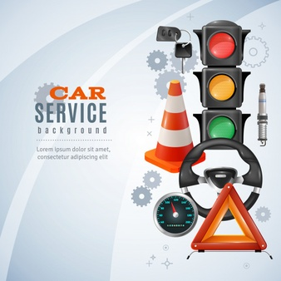

**Background Story:** We think we know all common law related to traffic, personal safety etc. but most of the time we don’t have clear idea about it. A quiz based app based on this law will help user to challenge his known knowledge and learn correct one.

**Raw Features & Function:**

A quiz base app for grow awareness in daily life for the people of different age group about,

1. Traffic rules & law
2. Safety issue at home, at work
3. Cyber law
4. Emergency
5. User Profile

**Each quiz contains:**

1. – Enough information

2. – Graphical presentation

3. - Time constraint (in competition)

**User will earn:**

• Points

• Badge

User can share badge, achievements in social media.

**The following are described in details:**

**1.Traffic rules & law:**

**It will have two parts, one is the learn part and the other is the quiz part.**

**Learn:**

**Traffic rules:**

* When the passenger move on the road he should use pavement, over-bridge and zebra-crossing side.

1. Use the over-bridge to cross the road.
2. You Must walk on the sidewalk while walking along the road.

* If the road is broken or if there are any holes in the road, then we have to walk the road very carefully so that you do not encounter any accident. Whenever walking on the road where repair work is being seen, where the signboard is placed, it should be well seen & forward.
* If a tree falls on the road due to a storm or for some other reason than everyone in the public has to come forward or contact those in the communications management or the police stations.
* The entire road is blocked to allow any VIP person to go through the road, causing a lot of jam on the road. After they leave the general public has to drive by accident to get to their destination. Then the public should follow the traffic laws rather than hurry.
* In the case of freight cars or trucks, it causes an accident by overtaking to carry extra loads.
* Passenger cars can cause accidents due to excess passenger carrying.
* Traffic laws must be obeyed when ambulances are hospitalized by injured people.
* You must drive on a fixed lane while driving on the road.
* Adhere to the traffic rules and traffic lights so that traffic jams are not.
* Drivers should avoid talking on the phone, falling asleep, smoking or drinking while driving on the road.
* When driving we must take a seat belt and then drive the car.
* When driving, you must take a seat belt and then drive the car.
* Illegal parking and extra passenger traffic are prohibited on the roads.
* Can't play loud horn.
* Without a fitness certificate, you cannot drive without a driving license.
* While driving, the speed of the vehicle must be kept in control where it is said to reduce the speed of the vehicle.

Road signs in Bangladesh: <https://en.wikipedia.org/wiki/Road_signs_in_Bangladesh>

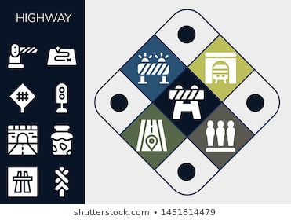

**Law:**

|  |  |  |
| --- | --- | --- |
|  | **New Laws** | **Existing laws** |
| **Offence** | **Punishment** | **Punishment** |
| Driving without license | 6 months jail with Tk. 25000 fine | 4 months jail with Tk.400 fine |
| Vehicle without registration | 6 months jail or Tk. 50,000 fine or both | 3 months jail or Tk. 2,000 fine or both 9 (for first time)/ 6 months jail or Tk. 5,000 fine or both (for second time) |
| Unfit Vehicles | 6 months jail or Tk. 25,000 fine or both | 3 months jail or Tk. 2,000 fine or both 9 (for first time)/ 6 months jail or Tk. 5,000 fine or both (for second time) |
| Vehicles without route permit | 6 months jail or Tk. 25,000 fine or both | 3 months jail or Tk. 2,000 fine or both |
| Meter tempering | 6 months jail or Tk. 50,000 fine or both | None |
| Body Modification | 3 years jail or Tk. 300,000 fine or both | 2 years jail or Tk. 5,000 fine or both |
| Over speeding | 3 months jail or Tk. 10,000 fine or both | 3 months jail or Tk 5000 fine or both |
| Honking banned horns | 3 months jail or Tk. 15,000 fine or both | Tk 200 fine |
| Using wrong route | 3 months jail or Tk. 10,000 fine or both | Tk 200 fine |
| Violating traffic signals | 3 months jail or Tk. 10,000 fine or both | 1 months jail or Tk. 500 fine or both |

**🛂Quiz:**

We have to answer the quiz to prove that this apps user has seen or learned it.

To play the quiz, he has to press the option and see all the questions and give the correct answer. Each answer will be given 5 seconds which he has to give very quickly.

He will be given a number or batch based on the quickest answer to all the quizzes.

Like as:

1. When pedestrians are on the road, what do they have to use?

 Ans: Footpath, foot over bridge, zebra-crossing.

1. Among the hundreds of people, should the people walk the streets?

Ans: Traffic law.

1. What is the reason for over-taking?

Ans: There are accidents.

1. What will be the reduction of traffic laws?

Ans: Traffic jam.

1. What must a driver do to drive a car?

Ans: Driving licenses.

1. What happens when parking on the streets?

Ans: There will be traffic congestion on the roads.

1. You must check the car before exiting the car on the road. Otherwise, what will happen?

Ans: The road has to be worn.

1. What if you don't use a helmet while riding a bike on the road?

Ans: Fine to be paid.

**2.Safety issue at home, at work:**

**It will have two parts, one is the learn part and the other is the quiz part.**

**Learn:**

* Follow the traffic laws Use the zebra crossing or the foot over bridge to tell others. Life's worth more than time. Do not park on the street without parking. Don't make noise by playing the horns unnecessarily.
* While renting a house, it is necessary to rent with all the information of the tenant. That's why our government is very quick, so collect the rental from your nearest police station.
* To prevent dengue, we need to be aware of ourselves. Water that is stored around the house must be removed so that no Aides mosquitoes can grow.
* Do not put water in the bucket at home so that young children do not have any accident at home. Keep money or small things out of his reach.
* Fire extinguishers should be placed in each building so that no major accidents occur. Check the elevator of your home for 6 months, except that you need to clean your home's water tank 3 times a day.
* Do not burn your home's gas stove so our gas is a natural resource. Check whether any gas leaks into the gas pipeline or stove.
* In our apps you can find out more about what to do to prevent a major accident and how to solve it.
* Drivers need to be aware that in CNG, the engine can be caught on fire for a long time. The driver of the CNG will have to test the mechanism when the driver is to reach the destination with CNG.
* In the case of any accident in the residence of the people, in the case of any accident, first aid should be provided and the first aid box should be collected.

**🛂Quiz:**

We have to answer the quiz to prove that this apps user has seen or learned it.

To play the quiz, he has to press the option and see all the questions and give the correct answer. Each answer will be given 5 seconds which he has to give very quickly.

He will be given a number or batch based on the quickest answer to all the quizzes.

Like as:

1. What happens if the car is not parking at the specified location?

Ans: The law will be disobeyed / the law will be punished for the violation.

1. What happens when playing the horn unnecessarily?

Ans: noise is pollution.

1. What to do if water is frozen around the house?

Ans: Otherwise it will be dengue.

1. What happens when the Aides mosquito bites?

Ans: Dengue is fever.

1. What is the use of a machine to control the flames?

Ans: A fire extinguisher.

**3.🚼 Cyber law:**

**It will have two parts, one is the learn part and the other is the quiz part.**

**Learn:**

Our cybercrime options will tell you about the various cyber related problems and solutions. The video or animation will be easy for everyone to understand.

Because now we have to use our internet smart technology smart devices to improve our quality of life.

Email, Facebook, emo, send daily companion we have to use many times every day. We have to deal with these problems on a regular basis. In addition to Facebook blackmail, rumors, harassment, many people have to give their lives.

That's why we all need to know about cyber law. Here you will find ideas on how to avoid various cybercrimes and also fully understand what steps our government has taken.

Our Bangladeshi government is very aware of such ambitions, so they have formed a separate cell called the cybercrime Branch.

Web side links: <https://youtu.be/_-n1q22xYDM>

Danger signals link:

<https://fscluster.org/sites/default/files/documents/Annex%2014_%20Tropical%20Cyclone%20Category%20System%20Overview%20and%20Early%20Warning.pdf>

**🛂Quiz:**

We have to answer the quiz to prove that this apps user has seen or learned it.

To play the quiz, he has to press the option and see all the questions and give the correct answer. Each answer will be given 5 seconds which he has to give very quickly.

He will be given a number or batch based on the quickest answer to all the quizzes.

Like as:

1. What kind of technical equipment do we use the most in modern technology?

Ans: Mobile, tab or computer.

1. Where do we know about technical problems?

Ans: At the Crime Branch in Sybil.

1. What are the things you keep secret when opening an account on Facebook, Emu, Gmail etc?

Ans: Password.

1. What would you do if someone tried to blackmail you online?

Ans: I will call at Crime Branch of Saber.

1. How do you spread rumors, fake news or fax news through social media?

Ans: If you share something without verifying.

**4.🛅 Emergency:**

**It will have three parts, one is the learn part and the other is the quiz part.**

**Learn:**

In adverse conditions such as storms, earthquake tidal, tsunami, landslides will also actually go directly to the nearby shelter. Moreover, candle lamps should be kept with dry food, food water, mobile phones, radios, torch lights. Before leaving your home, check that the gas line electrical lines are all off. As soon as you receive a government warning signal, everything has to go to the shelter.

If there is an empty area around your home during an earthquake, you should leave immediately. If there is no vacancy, shelter can be taken under the hard floor of your living room or under the bed.

Avoid using the elevator Do not hurry Use the stairs. Use that emergency number in case of an emergency. The citizens of Bangladesh can benefit from using this app to be aware of many more urgent things like this.

**Emergency number:**

999:Emergency Call Center in Bangladesh. Here you can get the help of police, fire service and ambulance in an emergency by calling for free. You can also report any crime and inform the police.

106: Call Center of the Anti-Corruption Commission. If any corruption is noticed, please call for free.

16430: Government Legal Aid Call Center. Call Free to get any legal advice or help.

16123:Call anybody for any advice on agriculture, fishery and livestock. Call this number for free if you see women being abused and forced into marriage.

1098:Child Support Main Call Center. If you have any problems around the children, you can call this service for free.

100- BTRC call center.

16420-BTCL Call Center.

09654333333:Provas service.

10941:Disaster arrival message.

16236:Bangladesh Bank.

333: National Information Awareness Call Center. Call this number to find out any information in Bangladesh and talk to government officials. (Charges apply)

16263:Health Call Center of the Government of Bangladesh. Please consult a specialist doctor within 24 hours for any problems. (Charges apply)

16108:Human Rights Assistant Call Center. Call this number if human rights are violated. (Charges apply)

 16256:Call the Union Assistant Call Center for all your union information. (Charges apply)

131:Bangladesh Railway Call Center. Call to find out about trains and tickets. (Charges apply)

105:National Identity Card Call Center. (Charges apply)

**‘Take care to stay healthy**

**We are always at your service**

**........ Bangladesh Helpline family’**

**🛂Quiz:**

We have to answer the quiz to prove that this apps user has seen or learned it.

To play the quiz, he has to press the option and see all the questions and give the correct answer. Each answer will be given 5 seconds which he has to give very quickly.

He will be given a number or batch based on the quickest answer to all the quizzes.

Like as:

1. Can you get help from the police, fire service ambulance when you call on a number at an urgent moment?

Ans: 999

1. Why use the number on children and violence?

Ans: 1098

1. Where to seek shelter during a natural disaster?

Ans: At the nearest shelter.

1. What things need to be kept close to during a natural disaster?

Ans: Candles, lamps, dry food, dishes, mobile phones, radios, torch lights, etc.

1. If you need to get out of your home during a natural disaster, what should you do?

Ans: Gas lines and electric lines have to be shut down.

**5.♿User Profile:**

We need to make a profile for the user to login to this app first. This will add his mobile number or email address and he can add his picture if he wants.

If any of our Apps users have any problems at any time, they will be given five vacancies to add their family members, parents' siblings' friends' names or email addresses.

If he has any problems then the specific S.O.S. Pressing the button will send a message to the concerned relatives or family to know its location along with a link to Google Map.

Moreover, he can speak directly to the emergency number of Bangladesh by pressing the 5 button.

1. Email + Photo
2. His phone number
3. Parents Emergency Number
4. SOS Button for Send Messages to All Numbers with Google Map links.
5. Bangladesh Other Emergency Numbers.

**Usage Area & Users:**

The market or audience would be people in the Bangladesh who regularly Work inside and outside home for their safety issue and awareness our Bangladesh people about our Law. This application usage Area Bangladeshi Nonprofit Organization, Social Organization, Police, Fire Service, School, collage, House.

How it is useful:

This would be particularly important for Our Country, where there is no Educational Course to know our country Useful law for Our regular life. Such as Traffic rules is mandatory to drive motor vehicles and we must know the Traffic Rules Bangladesh. We are here to present all about Traffic rules in this Traffic rules app in Bengali. According to Traffic rules Bangladesh each driver should carry Driving license, insurance and other necessary documents paper with them.

The Home Safety is a tool for fire departments and others doing home safety to make those even more effective. It provides you with a series of brief videos that can be shown on smartphones and tablet computers to help educate residents. Four important home fire safety topics are included:

• Cooking

• Heating

• Smoke Alarms

• Speed of Fire

The content in this App is provided as it is published by Ministry of Law, Bangladesh. We are just providing this App to facilitate students and others so that they can easily study/explore the Cyber Law Bangladesh.

This Section aims to provide one single common platform for awareness, education, protection, remediation, recourse, treatment and attempts to provide solution(s) with respect to Cyber Incident(s), Computer Related Offence(s), Cyber Crime, Cyber Law, Data Protection, Privacy, Incident Response and Safety. This app is a developed with the need and demand of changing times when people are spending almost 8-10 hours of their day using technology (Mobile for work/leisure and being connected 24x7 & Computer Systems for work).This app shall help in changing the culture and mind-set with respect to Information Security, Data Protection and Privacy of users and eventually being proactive in approach and follow basic hygiene regime with respect to Cyber Crime, Computer Related Offence, Bank Frauds, Identity Theft, and so on.

This app shows the main emergency and fire signals used in mining, oil, electrical and other industries. Over 30 free emergency sounds, police, fire, ambulance, coastguard, fire, nuclear, tornado, aliens and more.

It allows you to bookmark the most consulted emergency and fire signals and share them by mail, WhatsApp, among others. Thus becoming a great essential tool for security on your mobile device.

Similar apps & its features:

Motor law ~ Traffic rules

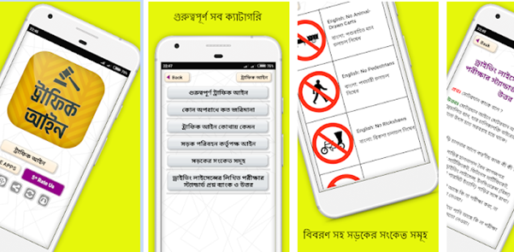

[https://play.google.com/store/apps/details?id=com.appsplatform.trafficrulesappbangladesh](https://play.google.com/store/apps/details?id=com.appsplatform.trafficrulesappbangladesh%20)

Traffic Rules & Sign - Challan Learning

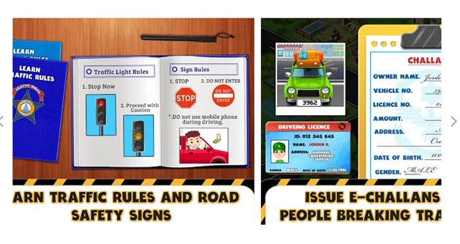

[https://play.google.com/store/apps/details?id=com.trafficgames.TrafficRulesEchallanLearning](https://play.google.com/store/apps/details?id=com.trafficgames.TrafficRulesEchallanLearning%20)

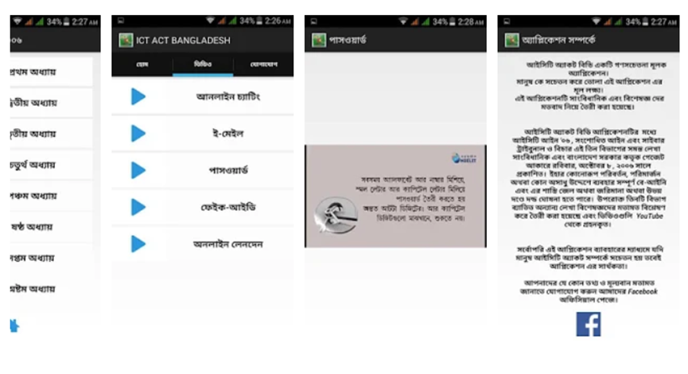

[https://play.google.com/store/apps/details?id=four.ingenium.cyberactbd](https://play.google.com/store/apps/details?id=four.ingenium.cyberactbd%20)

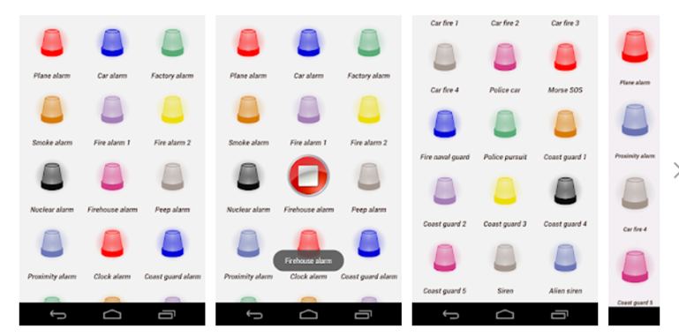

[https://play.google.com/store/apps/details?id=com.appslejandro.emergencysounds](https://play.google.com/store/apps/details?id=com.appslejandro.emergencysounds%20)

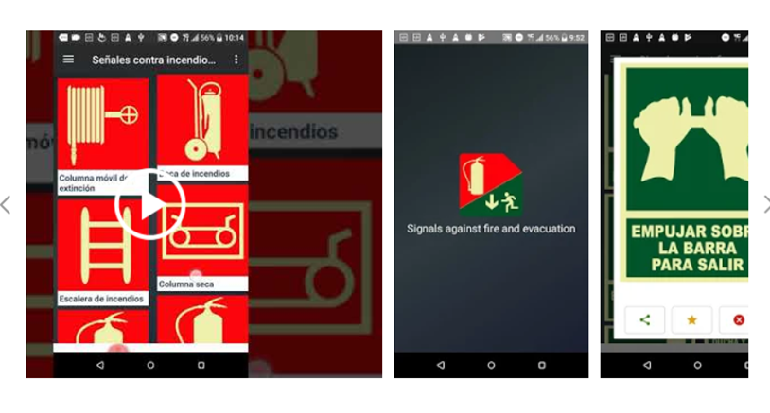

<https://play.google.com/store/apps/details?id=com.fjapps.juanc.senalesincendioemergencia>